Smart Agriculture Supply Chain With Blockchain Based Transparency

Prof. Md. Tauseef
School of ELECTRONICS AND
COMMUNICATION
REVA University Bangalore, India 27tauseef@gmail.com

Chandu M
School of ELECTRONICS AND
COMMUNICATION
REVA University Bangalore, India chandu.m1908@gmail.com

Chandan B Krishna
School of ELECTRONICS AND
COMMUNICATION
REVA University
Bangalore, India chandanbk.work@gmail.com

J A Dharma Sudeep
School of ELECTRONICS AND
COMMUNICATION
REVA University
Bangalore, India dharmasudeep212@gmail.com

Abstract—Agricultural supply chains suffer from limited transparency, fragmented data storage, and delayed traceability, which negatively impact food safety and farmer welfare. Traditional systems rely on manual record-keeping and centralized intermediaries, resulting in information asymmetry and lack of trust among stakeholders. This paper presents AgriChain, a blockchain-based agricultural supply chain management system that enables secure and transparent tracking of agricultural produce from farm to consumer. The proposed system is built on Hyperledger Fabric, a permissioned blockchain platform that ensures data integrity, access control, and scalability. Smart contracts automate transaction validation and pricing enforcement, while IoT sensors and QR code technology enable real-time monitoring and product verification. The results demonstrate improved traceability, accountability, and trust compared to conventional supply chain models, highlighting the effectiveness of blockchain technology in modern agricultural ecosystems.
- Introduction

Agriculture plays a critical role in economic development and food security, involving a complex network of stakeholders such as farmers, processors, logistics providers, retailers, and consumers. With the increasing scale of agricultural production and global trade, supply chains have become more intricate and data-intensive. However, most agricultural supply chains continue to operate on fragmented and centralized information systems, where data is stored in isolated databases or manual records. This lack of integration results in poor visibility across the supply chain, delayed information exchange, and limited accountability among participants.
The lack of an integrated and transparent data management framework has led to several persistent challenges such as limited traceability, delayed information sharing, and weak accountability mechanisms. In traditional systems, data is often stored in isolated databases controlled by individual stakeholders, making it difficult to verify product authenticity and quality across the supply chain. As
- Problem Definition
The existing agricultural supply chain infrastructure is characterized by fragmented data storage, manual record- keeping, and centralized control by intermediaries. Information related to crop origin, farming practices, quality certifications, storage conditions, and logistics is maintained in separate systems or paper-based records, leading to data inconsistency and vulnerability to manipulation. During food safety incidents or product recalls, tracing the source of contamination requires manual investigation across multiple stakeholders, often resulting in significant delays and economic losses.
Moreover, the lack of real-time monitoring and transparent information sharing creates information asymmetry among stakeholders. Farmers are unable to verify pricing and market data, while consumers lack visibility into upstream supply chain activities.
- Objective
The primary objective of this research is to design and develop a blockchain-based agricultural supply chain management system that ensures transparency, security, and end-to-end traceability of agricultural products. The proposed system aims to create a decentralized and tamper-proof framework in which all supply chain transactions are securely recorded and verified. By leveraging a permissioned blockchain platform, the system seeks to enable controlled data sharing among authorized stakeholders, thereby improving accountability and reducing the risk of data manipulation and fraud.
Another key objective of the proposed work is to enhance operational efficiency and trust across the agricultural supply chain by integrating smart contracts and IoT technologies. Smart contracts are used to automate transaction validation, pricing enforcement, and settlement processes, minimizing dependency on intermediaries and manual intervention. IoT- based monitoring enables real-time tracking of environmental and logistics conditions, ensuring product quality and safety. Through these mechanisms, the system aims to improve farmer.

- Literature Survey

Title | Authors | Description | Research Gap
Blockchain- Based Traceability in Agri-Food Supply Chain (2019) | Tian Feng | Uses RFID and blockchain to improve agri- food product traceability | No consume r interacti on or pricing transpare  ncy.
A Systematic Literature Review of Blockchain Applications | Francisco Casino, Thomas  K. Dasaklis, Constantinos  Patsakis | Reviews blockchain use cases and enterprise challenges. | Lacks agricultur e-specific implemen tation.
Blockchain- Based Agri-Food Supply Chain Framework | Shahid Raza, Linus Nordström, Amir Houmansadr | Applies blockchain and smart contracts for supply chain trust. | Limited consumer- facing transparen cy.
Ontology- Driven Blockchain Design for Supply Chain Provenance | Henry M. Kim, Marek Laskowski | Uses semantic models to improve provenance tracking. | Mostly conceptua l, limited deployme nt
Blockchain and IoT Integration for Supply Chain Management | Abderahman Rejeb, Karim Rejeb, Horst Treiblmaier | Combines IoT and blockchain for real-time monitoring. | No agricultu ral impleme ntation validatio  n.
Review of Blockchain- Based Agri- Food Traceability Systems | Hao Feng, Xiaohui Wang, Yuhui Duan | Evaluates blockchain- based agri- food traceability models. | Ignores pricing and stakehold er interactio  n.
Secure and Transparent Agricultural Supply Chain Using Blockchain | Qiang Lin, Hua Wang, Xiaofei Pei | Proposes secure and decentralized data sharing. | Lacks real-time IoT integratio n.
Blockchain Opportunitie s in the  Agri-Food Industry | Marco Tripoli, Jörg Schmidhuber | Discusses blockchain for governance and fraud reduction. | No system design or impleme ntation.
Blockchain in Agriculture and Food Supply Chains | Andreas Kamilaris, Agusti Fonts, Francesc X. Prenafeta- Boldú | Analyzes transparency and sustainability benefits. | Needs practical deploym ent models.
Secure Data Sharing in Agricultural Supply Chains Using Blockchain | Mohammad Salahuddin, Md. Zakirul Alam, Nayeem Islam | Focuses on blockchain-based secure data sharing. | Missing automated traceabilit y mechanis ms.
TABLE I Literature Survey
- Methodology

The proposed blockchain-based agricultural supply chain system follows a structured, sequential, and traceability-driven methodology aimed at ensuring transparency, data integrity, and trust among all supply chain participants. The workflow of the proposed system is illustrated in Fig. 1. The methodology is designed around a permissioned blockchain environment, enabling secure participation of authorized stakeholders while maintaining scalability and privacy. The overall process consists of ten major stages, described as follows.
  - Farmer Registration and Batch Creation: The system operation begins with farmer registration, where farmers are onboarded into the permissioned blockchain network through identity verification and role assignment. During onboarding, basic farmer credentials and authorization details are validated by the network administrator. After successful registration, the farmer creates a new agricultural batch by entering key information such as crop type, quantity, harvest date, cultivation location, and farming method. This batch creation process establishes the digital identity of the produce and marks the formal initiation of its lifecycle within the blockchain- enabled supply chain.
  - Blockchain Storage of Batch Information: Once the batch is created, all associated information is securely stored on the blockchain as a transaction. The immutable nature of blockchain ensures that the recorded batch data cannot be altered or deleted, thereby preventing fraud and unauthorized manipulation. This step provides a single source of truth accessible to all authorized stakeholders and enables auditability throughout the supply chain lifecycle.
  - QR Code Generation: After successful blockchain registration of the batch, a unique QR code is generated and linked to the corresponding blockchain record. The QR code acts as a digital identifier that connects the physical product with its immutable data stored on the blockchain. This identifier is attached to the product packaging and remains unchanged throughout subsequent stages, enabling seamless traceability.
  - Quality Inspection Recording: In this stage, authorized quality inspectors or regulatory authorities conduct inspections to verify product quality, compliance standards, and certification status. Inspection results such as grading, quality metrics, and approval status are recorded on the blockchain. By permanently storing inspection records, the system enhances accountability and enables stakeholders to verify compliance without relying on third-party documentation.
  - Transfer to Processor or Logistics Provider: Following quality verification, ownership of the batch is transferred to processors or logistics providers. Each transfer event is recorded as a blockchain transaction, capturing critical details such as timestamp, location, sender, and receiver identity. This continuous logging ensures transparent tracking of product movement and prevents disputes related to the product handling or the ownership of the products.

  - Price Update and Payment Release: Pricing information is updated based on predefined business rules embedded within smart contracts. Once the agreed conditions are satisfied, such as delivery confirmation or quality approval, the smart contract automatically triggers payment release to the farmer. This automation reduces intermediary dependency, minimizes payment delays, and promotes fair pricing mechanisms across the supply chain.
  - Retail Sale Recording: After processing and transportation, the agricultural product reaches the retail stage. Retailers record the final sale details on the blockchain, including sale date and product status. This transaction completes the commercial flow of the product and ensures end-to-end visibility from production to point of sale.
  - Product Traceability Display: Consumers can scan the QR code using a mobile device at the point of purchase or post-purchase. This action retrieves verified product information directly from the blockchain, ensuring authenticity without dependence on centralized databases or manual records.
  - Product Traceability Display: Upon scanning, the system displays complete traceability information in a user- friendly format. This includes details such as farm origin, batch creation data, quality inspection results, logistics history, pricing updates, and retail records. Providing transparent access to this information enhances consumer trust and awareness.
  - End of Supply Chain Lifecycle: The process concludes once the product traceability information is accessed by the consumer. However, the blockchain record remains permanently available for audits, regulatory verification, and dispute resolution. This ensures long-term accountability and data availability beyond the product’s consumption phase.
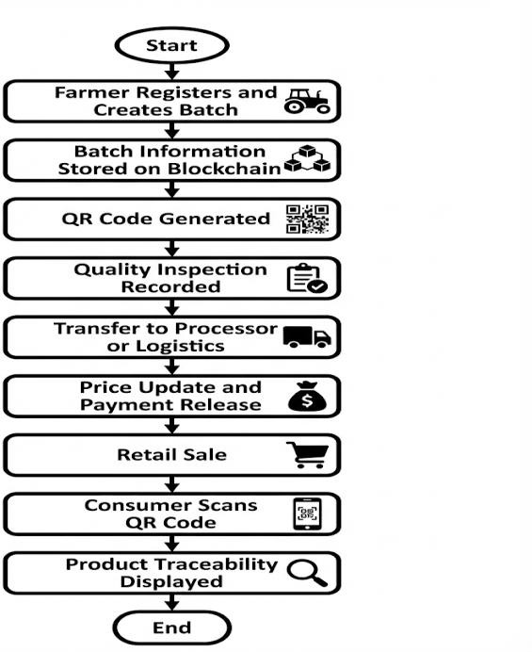
Fig. 3.1 Methodology
The workflow illustrates the sequential execution of the proposed blockchain-based agricultural supply chain system. It begins with farmer registration and batch creation, followed by secure storage of batch information on the blockchain and QR code generation. Quality inspection determines batch approval or rejection before transfer to logistics or processing units. Smart contracts automate pricing and payment release, after which retail sales occur. Finally, consumers scan the QR code to access complete, immutable product traceability information.
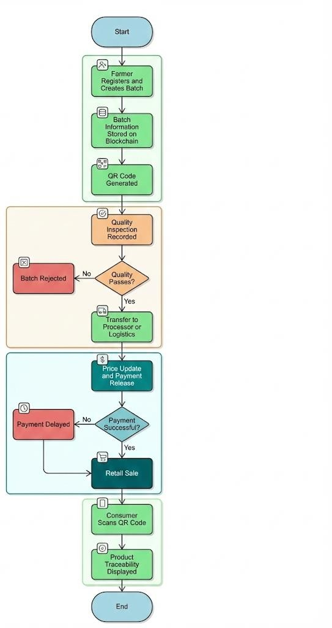

Fig. 3.2 System Workflow

- Proposed Work

The proposed work focuses on the design and implementation of a blockchain-based agricultural supply chain system that enables secure data sharing, end-to-end traceability, and automated transactions among stakeholders. The system is developed using a permissioned blockchain framework to ensure controlled participation, data privacy, and scalability. The solution incorporates smart contracts to automate critical processes such as batch creation, ownership transfer, quality verification, pricing updates, and payment settlement. In addition, IoT data interfaces support real-time monitoring of logistics and environmental conditions, while role-based user applications provide transparent access, visualization, and verification of supply chain information, effectively addressing the limitations of conventional agricultural supply chain systems.
    - System Architecture: The architecture of the proposed system follows a layered approach consisting of the user layer, application layer, blockchain layer, and data integration layer. The user layer includes all supply chain participants such as farmers, quality inspectors, processors, logistics providers, retailers, regulators, and consumers. Each participant interacts with the system through role-based access mechanisms to ensure secure and authorized operations.
The application layer provides web and mobile interfaces for data entry, monitoring, and traceability visualization. Farmers use this layer to create product batches and track ownership, inspectors record quality assessments, logistics providers update transportation details, and retailers record sales transactions. Consumers access the system through QR code scanning to view verified product history.
At the core of the architecture lies the blockchain layer, implemented using Hyperledger Fabric. This layer is responsible for maintaining the distributed ledger, validating transactions, and executing smart contracts. Smart contracts encode business logic for batch creation, ownership transfer, quality verification, pricing updates, and payment release. The permissioned nature of the blockchain ensures high throughput and controlled data access among stakeholders.
The data integration layer supports the incorporation of external data sources such as IoT sensors used for monitoring environmental and logistics conditions. To optimize performance, sensor data is stored using a hybrid approach, where large datasets are maintained off-chain while cryptographic hashes are recorded on-chain to preserve data integrity and traceability.
    - Functional Modules: The Farmer Registration and Batch Management Module enables verified farmers to register and create agricultural product batches. This module records crop-related details such as harvest date, quantity, and location on the blockchain, establishing digital ownership and initiating the supply chain lifecycle.
The Blockchain and Smart Contract Module manages
secure storage of supply chain transactions and automates operational processes. Smart contracts enforce predefined rules for ownership transfer, quality approval, pricing updates, and payment settlements, reducing reliance on intermediaries and minimizing manual intervention.
The Quality Inspection Module allows authorized inspectors and regulatory bodies to record inspection results, certifications, and compliance information. These records are permanently stored on the blockchain, ensuring accountability and enabling auditability across the supply chain.
The Logistics and Processing Module tracks the movement of agricultural produce through processing, storage, and transportation stages. Each transfer event is logged on the blockchain with timestamp and participant details, ensuring continuous visibility of product movement.
The Pricing and Payment Module implements automated pricing updates and payment release mechanisms using smart contracts. This module ensures timely settlements and fair compensation to farmers, addressing pricing transparency issues prevalent in traditional supply chains.
The Retail and Consumer Traceability Module records retail sales and enables consumers to access complete product history through QR code scanning. By providing verified information on origin, quality, and logistics, this module enhances consumer trust and confidence in agricultural products.
- Results
The implementation of the Smart Agriculture Supply Chain with Blockchain-Based Transparency system was evaluated with respect to its ability to satisfy the defined system objectives at the frontend level. The results indicate that the proposed system successfully delivers a transparent, secure, and user-friendly solution for agricultural supply chain management, effectively supporting multiple stakeholders through role-based interaction.

Frontend Result Analysis
The developed web interface provides dedicated dashboards for farmers, intermediaries, retailers, consumers, and administrators. Each stakeholder is granted access only to role- specific information, ensuring data privacy and clarity. Farmers are able to create and manage product batches, intermediaries can record ownership transfers, retailers can view pricing history, and consumers can access product traceability information through QR code scanning. This role-based access mechanism improves usability and prevents unauthorized data exposure.
The QR code–based interface enables instant retrieval of blockchain-backed batch information by scanning the code attached to the product. This feature significantly enhances transparency and allows consumers to verify product authenticity and origin with ease. Additionally, the system visually represents traceability through a timeline that displays the complete journey of an agricultural batch from farm to consumer. The price evolution of each batch is also clearly shown across different supply chain stages, supporting better

understanding and decision-making.
Overall, the frontend implementation successfully fulfills its intended objectives by providing a user-friendly and role-based interface for all supply chain stakeholders. The system presents traceability and pricing information in a clear and structured manner, allowing users to easily understand product history and transaction flow. By improving information accessibility and visualization, the frontend enhances transparency, builds trust among participants, and increases overall stakeholder confidence in the agricultural supply chain system.
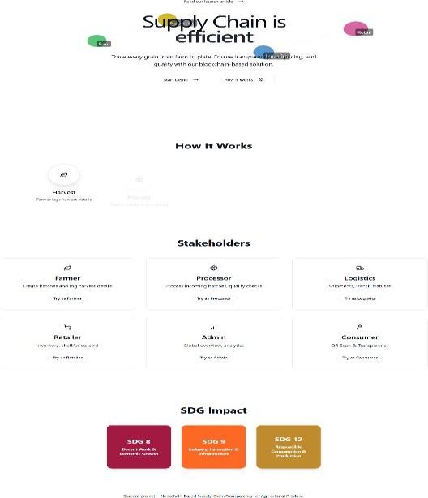

Fig. 5.1.1 Output - Homepage
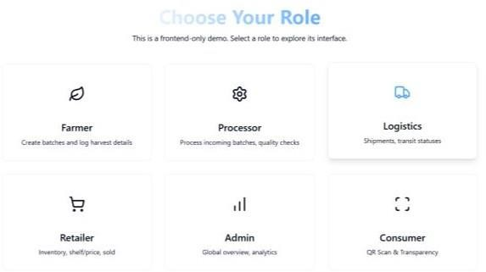

Fig. 5.1.2 Output - Role page
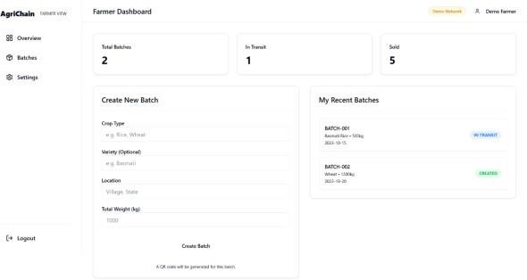
Fig. 5.1.3 Output – Farmer Dashboard

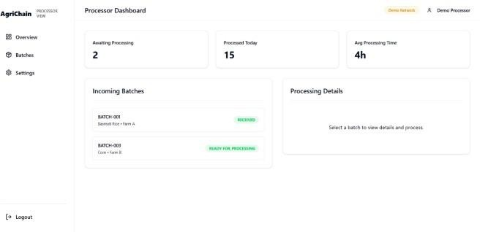
Fig. 5.1.4 Output – Processor Dashboard
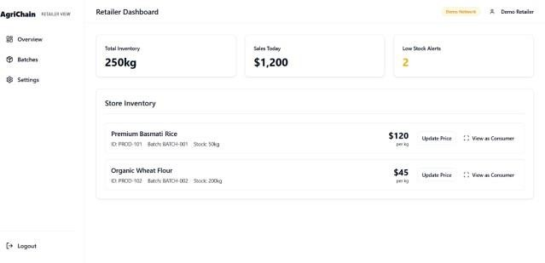
Fig. 5.1.5 Output – Logistics Dashboard

Fig. 5.1.6 Output – Retailer Dashboard

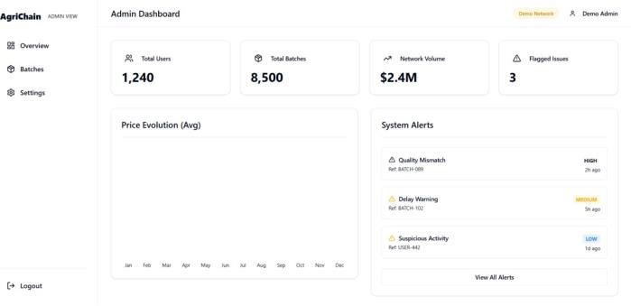

Fig. 5.1.7 Output – Admin Dashboard

\

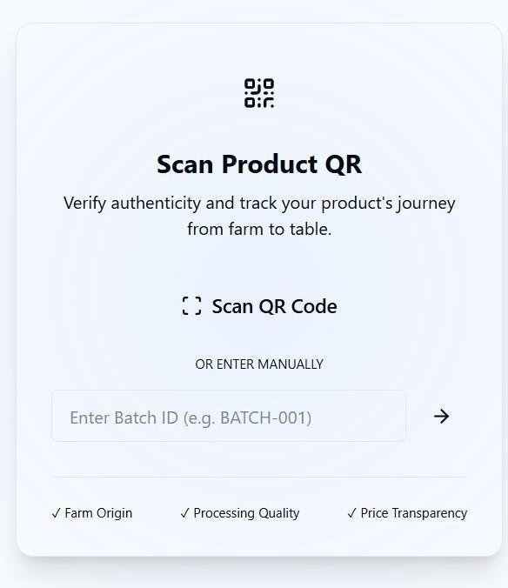
Fig. 5.1.8 Output – Admin Dashboard
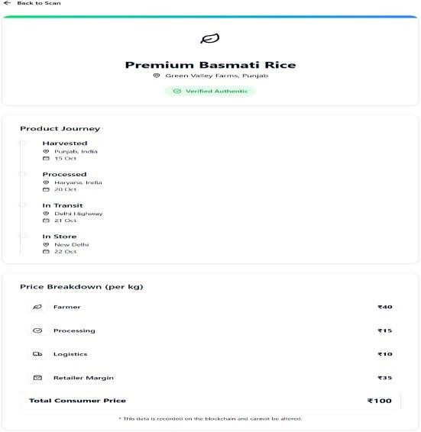

Fig. 5.1.7 Output – Admin Dashboard

Backend Result Analysis
The backend objectives focused on ensuring seamless integration between the frontend application, blockchain network, and off-chain database while efficiently managing data storage and synchronization. These objectives were successfully achieved through a well-structured backend design. The backend exposes clean and robust RESTful APIs that enable reliable communication between the user interface, blockchain smart contracts, and the off-chain storage layer. Consistent API responses ensure real-time data synchronization and smooth system operation across all modules.
The backend efficiently manages batch details, user data, inspection records, and pricing information using off-chain storage, reducing blockchain storage overhead. Integration with the blockchain through Ethers.js ensures secure recording of critical supply chain events. Backend references
enable fast data retrieval, analytics, and reporting. The system reliably supports batch creation, transfers, quality updates, and price tracking without data loss or inconsistency.

- Conclusion and Future Scope

The Smart Agriculture Supply Chain with Blockchain-Based Transparency project successfully demonstrates the effective application of blockchain technology in addressing critical challenges such as transparency, traceability, and trust within agricultural supply chains. By adopting a consortium-based, permissioned blockchain architecture, the proposed system ensures secure participation of authorized stakeholders while maintaining data integrity, immutability, and auditability. The implementation of smart contracts automates essential supply chain processes including batch creation, ownership transfer, quality verification, pricing events, payment release, and recall management, thereby reducing manual intervention and operational inefficiencies.
In addition, the integration of QR code–based traceability effectively bridges the gap between physical agricultural produce and digital blockchain records. This enables consumers, auditors, and regulators to access reliable and tamper-proof product histories. The frontend implementation provides role-based dashboards and visual traceability timelines that enhance usability and information clarity, while the backend architecture ensures seamless interaction between the user interface, blockchain network, and off-chain data storage. The successful achievement of both frontend and backend objectives confirms the reliability, scalability, and usability of the proposed system in real-world agricultural supply chain scenarios.
Future Scope: Future work can focus on enhancing the proposed system by integrating IoT-based sensing devices for automated monitoring of environmental and logistics conditions, enabling more accurate and real-time data capture. The application of artificial intelligence and advanced data analytics can further support demand forecasting, anomaly detection, fraud prevention, and intelligent pricing mechanisms. Extending the platform with mobile application support and multilingual interfaces can improve accessibility for farmers and field-level stakeholders. In addition, integration with government regulatory platforms, certification bodies, and sustainability assessment frameworks can strengthen compliance, standardization, and environmental accountability, allowing the system to evolve into a scalable and intelligent infrastructure for modern agricultural supply chains.

References
- [1] F. Tian, “An agri-food supply chain traceability system for China based on RFID and blockchain technology,” in Proc. 13th Int. Conf. Service Systems and Service Management (ICSSSM), 2016, pp. 1–6. Available: https://ieeexplore.ieee.org/document/7538424
- [2] M. Casino, T. K. Dasaklis, and C. Patsakis, “A systematic literature review of blockchain-based applications: Current status, classification and open issues,” IEEE Access, vol. 7, pp. 229–252, 2019. Available: https://ieeexplore.ieee.org/document/8636242
- [3] A. Shahid, A. Almogren, N. Javaid, et al., “Blockchain-based agri-food supply chain: A complete solution,” IEEE Access, vol. 8, pp. 69230– 69243, 2020. Available: https://ieeexplore.ieee.org/document/9166000
- [4] S. Kim and R. Laskowski, “Toward an ontology-driven blockchain design for supply-chain provenance,” IEEE Intelligent Systems, vol. 33, no. 1, pp. 52–59, 2018. Available: https://ieeexplore.ieee.org/document/8274982
- [5] A. Rejeb, J. G. Keogh, and H. Treiblmaier, “Leveraging the internet of things and blockchain technology in supply chain management,” IEEE Engineering Management Review, vol. 47, no. 3, pp. 95–105, 2019.
Available: https://ieeexplore.ieee.org/document/8737467
- [6] H. Feng, X. Wang, Y. Duan, J. Zhang, and X. Zhang, “Applying blockchain technology to improve agri-food traceability: A review,” IEEE Access, vol. 8, pp. 110859–110870, 2020. Available: https://ieeexplore.ieee.org/document/9102568
- [7] Y. Lin, J. Shen, and C. Zhang, “Blockchain-based systems for secure and transparent agricultural supply chains,” in Proc. IEEE Int. Conf. Blockchain, 2019, pp. 1–8. Available: https://ieeexplore.ieee.org/document/8946182
- [8] M. Tripoli and J. Schmidhuber, “Emerging opportunities for the application of blockchain in the agri-food industry,” IEEE Engineering Management Review, vol. 46, no. 4, pp. 14–24, 2018. Available: https://ieeexplore.ieee.org/document/8513552
- [9] A. Kamilaris, A. Fonts, and F. X. Prenafeta-Boldú, “The rise of blockchain technology in agriculture and food supply chains,” IEEE Access, vol. 7, pp. 45558–45576, 2019. Available: https://ieeexplore.ieee.org/document/8691399
- [10] S. Salahuddin, A. Al-Fuqaha, and M. Guizani, “Blockchain-based secure data sharing for agriculture supply chains,” IEEE Communications Magazine, vol. 58, no. 8, pp. 28–34, 2020. Available: https://ieeexplore.ieee.org/document/9155273

